BLOGPOST - The Right Team & Roles

The Right Team & Roles
From Launch to Series A: 10 Prios Before You Reach 10k MRR — SaaS SMBs Ed.
Priority 4: The Right Team & Roles

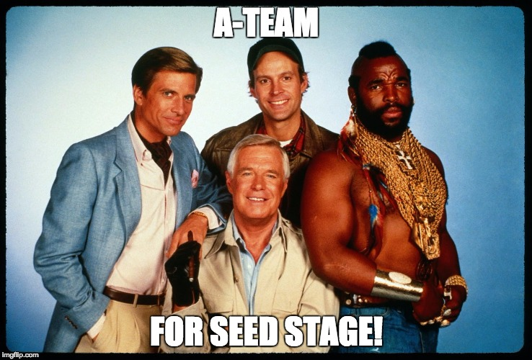
Keep your team small …
At this early stage your team is small and everybody has lots of responsibility — in practice, everybody is a founder even if that’s not reflected in shares. This means that each hire can bring lots of success or lots of trouble to your fledgeling company. Not only due to their skills and attitude to get the job done, but also because every extra role/function/person added to your team has far-reaching implications:
a) Most importantly it reduces your runway. At the early stage, as obvious as it sounds, most companies die because they run out of money.
b) It adds extra complexity and burden to managing your team. You, as the CEO, will probably need to set their priorities and they would want your attention to validate their results.
c) It makes communication more complex. The more people in a team or organisation, the harder it becomes to communicate efficiently.
d) It spreads the feedback you’re gathering from your customers into more people. That might be positive if they bring great points, but it might also make it harder to iterate if the key people in the team don’t have all the info they need.
You should note that there are many opinions ahead. First of all, I will try to explain what the main functions are that should be delivered at this phase. Then, I will suggest who should take care of those functions. The key principles guiding this rationale are:
Pareto rule (or radical focus): Do VERY few things that have the highest amount of leverage
Buy time to iterate quickly. With few people, you can extend your runway. By doing this you can also iterate faster and better which further increases your chances of success.
… Covering the right functions
The main functions that need to be delivered, even at an early stage, are:
Product: Understand what the customers REALLY want and align it with your vision.
Engineering: Build that as FAST as possible and as RELIABLE as REQUIRED for the current demands. Not more, not less, that’s the art.
Design: Make the product USABLE :)
Customer successes: Decide WHICH PROBLEMS to solve for your customers and bring feedback to the team.
Sales: Prove that you’re solving a problem that customers want to PAY you enough to have a SUSTAINABLE and LARGE BUSINESS.
Marketing: Attract the RELEVANT early adopters.
HR: Keep your people happy. Hire the next one required and let go of the under-performing members.
Finance: Keep close control of your CASH :)
On your A-Team before 10k
When you look at the hires to be done for those jobs, some experienced founders might be able to raise the funding to appoint a CEO, a VP Product, a VP Eng, a VP Design, VP Customer success, VP Sales, VP Marketing, VP Finance, VP HR, etc. If you do that hiring top-down, then every key person in the organisation will build their team.
But chances are that you’re not so lucky to know all of these great people that you need, nor that you have the funding to afford them. Thus, at this early stage, one way of building that A-team could be:
CEO-founder owns: product, sales, customer success and HR.
The founder handles all of those functions first to get feedback from the market and learn what needs to be done. Then, she can understand what kind of hire will do well and the benchmark for performance.
Once you understand well those processes, the next business hires can be SDRs and/or customer support agents.


And that’s how a CEO founder of a startup can win discussions ;)
CTO-founder owns development and manages a couple of amazing developers.
Designer roles could be handled by a freelancer at this stage, but don’t be cheap here!
Marketing functions can be handled by a data-driven marketing guy. Bring him onboard sooner rather than later.
Finance can be outsourced — primarily the accounting, payroll, etc.
On early stage execs’ hiring
Obviously, don’t get blinded by this list and be sure to use common sense in relation to your own situation. If you attract an amazing candidate, bring him onboard even if it might be a bit too early. More than likely that the time they will save by knowing what they do will justify the higher expense. But a couple of words of caution here:


Make sure that they are still hungry and want to get their hands dirty
They should be productive without (many) additional resources
Make sure their most recent experience is similar to your challenges.
Basically, that marketing candidate from a large B2B tech company may be very unproductive to grow your leads from 0 to 100s, unless they have already done that before — and are willing to do all the hard work to do it again. Also, the expensive sales guy closing large checks might be unable to close a 500$/month deal for you.
Apart from that previous point. One important exception to “opportunistic hires” is the recruitment of a VP Sales. The chances of a failed hire are a lot lower when you do it past-100k MRR. Once you have a clear idea on how your sales process (kind-of) works.
StartupSaaSVenture CapitalTeam BuildingFounders
71
- Follow


Rodrigo Martinez
Investor in Startups @PointNineCap - Hobbyist developer - Spaniard abroad

Aus <https://medium.com/point-nine-news/the-right-team-roles-4-10-bf47196caba2#.bw1oaaq5p>

